HURTWOOD HOUSE

Curriculum Policy

Reviewed | By | Last reviewed | Last modified
Annually | SMT | Oct 2025 | Oct 2025

HURTWOOD HOUSE

CURRICULUM POLICY STATEMENT

The following School policies, procedures and resource materials are relevant to this policy:

- Teaching and Learning Policy
- Gifted and Talented Policy
- SEND Policy
- ESOL Policy
- PSHEE Policy
- RSE Policy
- Marking Policy
- Higher Education Advice and Careers Policy.

Hurtwood House aims to provide a broad, well-planned and balanced curriculum which is accessible to every student irrespective of gender, ethnicity or ability. In particular, the curriculum has been designed in order to meet the following school aims:

- To provide a balanced curriculum which values academic, creative and practical knowledge and skills equally
- To encourage each student to reach their potential through small, mixed ability classes, an awareness of individual learning needs and an emphasis on study skills and support
- To develop independence, self-discipline and good behaviour by guiding students to take responsibility for their own learning and development in and out of school time.
We are committed to providing a rigorous academic education which engages students in both the content of courses and the process of learning; which fosters intellectual curiosity and independent learning; and which provides a foundation for progression into higher education or the workplace.

The curriculum has been developed to allow all students, (including those with learning difficulties or English as an additional language) to access the eight areas of experience as defined in the ISSR: Part 1 - Quality of Education.

- Linguistic
- Mathematical
- Scientific
- Technological
- Human and social
- Physical
- Aesthetic and Creative
- Speaking, listening, literacy and numeracy.

SMSC

Through its curriculum provision, Hurtwood House commits to meeting the expectations set with regards to the spiritual, moral, social and cultural (SMSC) development of our students. The school actively promotes the fundamental British values of democracy, the rule of law, individual liberty and mutual respect and tolerance of those with different faiths and beliefs. Through the curriculum, the school will ensure that principles are actively promoted which:

- enable students to develop their self-knowledge, self-esteem and self-confidence;
- enable students to distinguish right from wrong and to respect the civil and criminal law of England;
- encourage students to accept responsibility for their behaviour, show initiative and understand how they can contribute positively to the lives of those living and working locally and to society more widely;
- enable students to acquire a broad general knowledge of and respect for public institutions and services in England;
- lead to further tolerance and harmony between different cultural traditions by enabling students to acquire an appreciation of and respect for their own and other cultures;
- encourage respect for other people, paying particular regard to the protected characteristics set out in the Equality Act 2010;
- encourage respect for democracy and support for participation in the democratic processes, including respect for the basis on which the law is made and applied in England.

Hurtwood House precludes the promotion of partisan political views in the teaching of any subject in the curriculum and takes such steps as are reasonably practicable to ensure that where political issues are brought to the attention of students they are offered a balanced presentation of opposing views:

- while they are in school;
- while they are taking part in extra-curricular activities, trips or visits which are provided, organised by or on behalf of the school;
- in the promotion at the school, including through the distribution of promotional material, of extra-curricular activities taking place at the school or elsewhere.

The A-Level Curriculum (2 year course):

The school offers a wide range of subjects, 20 in total, designed to accommodate the needs of today’s modern sixth former. There is no ‘Options’ structure nor any other constraint on subject choice. Students may opt for any combination of subjects which suit their interests, and which will ensure their progression after Hurtwood.

The school offers a fully linear A Level curriculum. All A Level courses are studied over a two-year period with final assessment in the summer term of the second year. Students do not sit any free-standing AS examinations at the end of the first year, although they are formally examined internally in both November and April of the first year in order to develop examination skills and ascertain progress.

Students typically study three A Level courses, although a small number of students do select four A Level subjects in the first instance in order to allow them some flexibility as they decide on their three confirmed courses in the first few weeks of the term.

Hurtwood House recognises the benefit of teachers meeting their classes on a daily basis and to this end the timetable has been arranged to accommodate 70 minute lessons in each subject each day.

The curriculum, and its delivery, aims to:

- Provide a broad, interesting and challenging choice of subjects
- Provide a staging post between school and university
- Encourage aspirational choices and access to higher education or the workplace
- Encourage independent learning and decision making
- Provide access to higher and continuing education
- Facilitate the acquisition of knowledge, skills and qualities which will help the student develop intellectually, emotionally, socially, morally and aesthetically so they may become independent, responsible, useful, thoughtful and considerate members of society
- Create an exciting and stimulating learning environment
- Ensure that there is a match with the skills the student possesses and the tasks he/she is asked to perform.

Life Skills - PSHEE

The A Level curriculum is supplemented by our co-curricular Life Skills programme. This encompasses the development of key study skills, a two-year enrichment programme (Enigma, in which students take a number of short courses in a diverse range of non-academic subjects and attend weekly PHSEE/RSE presentations or workshops), safe driving instruction, emergency aid training, personal finance, employability skills and a comprehensive careers and university application programme.

The (I)GCSE Curriculum (1 year course):

Each year the school welcomes a small cohort of overseas Foundation students who follow a designated programme of (I)GCSE subjects designed to prepare them for the transition onto the full A Level course. All Foundation students are expected to study English Language, Mathematics, Science (awarded as 2 IGCSEs) and Drama, as well as a fortnightly PHSEE/Life Skills session and a weekly sport/exercise session. (The (I)GCSE course at Hurtwood House equates to a student studying 8 or 10 GCSE subjects over a two year period.)

The workload is demanding and there is little free time during the working day. It is expected that students on this course will progress to the A Level curriculum provided they have shown evidence that they will cope with the academic rigour, language and self discipline required at the higher level.

Academic monitoring within the curriculum and student performance

Academic progress of all students is assessed each week in each subject and reported through attainment and effort grades which are available to the students, their personal tutors and their parents and/or guardians. The grades are reviewed each week as part of the tutorial process and used as the basis of ongoing academic advice and guidance.

The school undertakes baseline testing using the CABT ALIS test administered by CEM at the University of Durham. This allows the school to examine and measure its value added outcomes. This data has enabled the school to begin trialling a progress monitoring exercise showing the achievements of different groups within the school (EAL, IEPs, able) against their predicted achievement levels. ALIS test data is used with Heads of Departments to assess value added and explore effective teaching and learning strategies.

Sports and activities

Although there is no compulsory element to the sport and activity provision at Hurtwood for those students on an A Level programme, the timetable includes a daily Activities session in which students are strongly encouraged to take part in one of the many sporting, performance or other activities offered. Regular training sessions and fixtures are offered in rugby, football, hockey, netball, tennis and a number of other sports may be offered depending upon interest.

EAL/ESOL

Students whose first language is not English are assessed during the first week of the school year to identify their English language capabilities and needs. The appropriate development of English skills is provided through timetabled IELTS or IGCSE English lessons and, where appropriate, individual support. These lessons aim to develop the students’ English language skills and communicative ability and to build the students’ confidence to succeed in an English speaking environment. Assessment is offered by the International English Language Testing System (IELTS) or IGCSE English Language - depending upon ability, higher education demands or visa conditions - and run concurrently with either the A Level or (I)GCSE curriculum. The ESOL department work closely with other academic departments to ensure that students receive appropriate levels of English support. There are also close links with the Careers department to ensure that students are well prepared for the demands of university offers. Students who are taking four subjects are timetabled for ESOL classes outside of the normal lesson blocks and may not be able to participate in all weekly Activities and Enigma sessions, however all ESOL students are expected to participate in the programme of PHSEE sessions on Friday afternoons.

(I)GCSE Re-sit examinations

Upon joining the school, students who have sat (I)GCSE examinations and have not reached grade 4 in Mathematics or English, are identified (via examination results submission and registration questionnaire). These students are placed in timetabled classes in order to prepare them for re-sitting these IGCSE examinations in one of the next available series (appropriate to each individual student). A student may need more than one attempt to achieve the desired grade. From September of the A2 year, if a student has not achieved the required grade in IGCSE Mathematics, they will (with student and parental agreement) be moved to the Level 2 Functional Skills pathway. Timetabled lessons in this course will prepare them for a Spring examination entry.

Special Educational Needs and Gifted & Talented students

At Hurtwood we aim to identify students with specific learning needs early, either through information provided by parents or through the close weekly monitoring of academic progress. Students with SEN will present with an existing Educational Psychologist report or may be referred for an assessment by our Learning Support Coordinator. Once these needs have been identified, students work closely with their teachers to formulate an Individual Education Plan to support their work within the curriculum. These plans are reviewed and adapted at a termly Learning Meeting in each subject.

Gifted and talented students are provided with opportunities to extend their learning within the A Level curriculum and through extra-curricular instruction designed to provide stretch and challenge opportunities. Examples of these include:

- The Extended Project Qualification
- ‘Supermaths’
- Advanced English
- Advanced Economics
- Dance Company
- The Hurtwood Film Academy
- Acting Company
- Hurtwood Writers

Careers

A comprehensive Careers and University Advice and Application service is provided by our full time team of experts. A detailed programme begins in the second term of study; through a series of seminars, individual interviews, outside speakers and visits, all students are encouraged to make considered choices based upon their ambitions, their abilities and their curriculum and then supported through the process of application, interview and placement. Through this service, students receive impartial, up-to-date guidance which enables them to make informed choices about their options and ensures that they fulfil their potential.

Authorised by | resolution of the Partners  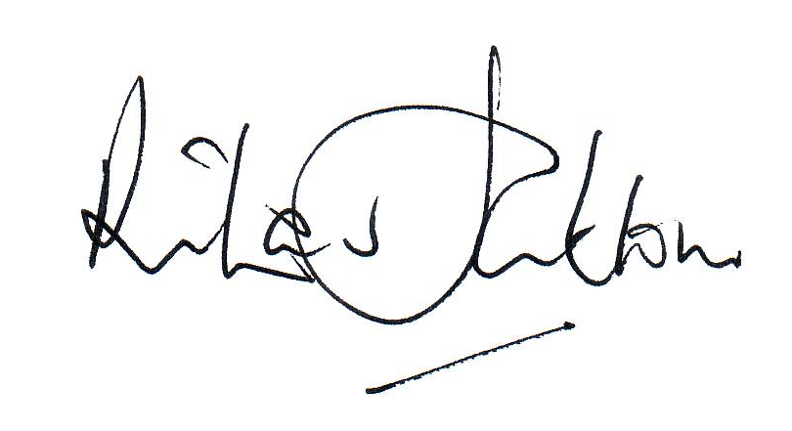  
Date | 24/06/2025

Effective date of the policy | 14th October 2025
Circulation | Partners / all staff / parents / students on request
Status | Complies with requirements the Education (Independent School Standards) (England) Regulations 2014

